Language, Literacy and Communication  Oracy  *Express what they like and dislike  *Show an awareness of alliteration and rhyme.  *Follow action words and commands.  *Talk about things they have made or done, adding some description  - Use a variety of questions (e.g. “Who?”, “What?”, “Why?”, “When?” and “How?”) to establish why things happen and to clarify understanding  - Answer “Who?, What?, Where? And open-ended questions relating to own experiences, stories and events  - *Use words, phrases and simple sentences.  - Exchange ideas one to one and in small group discussions  - Take part in activities alongside others with some interaction  Reading/Phonics Skills  - Link and identify a growing number of spoken sounds to letters  - Recognise that words are constructed from phonemes and that they are represented by graphemes  -orally blend combinations of known letters  -orally segment combinations of known letters  *Recognise high frequency words  *Apply and use context cues with support eg pictures, initial sounds  - Use one to one correspondence between written and spoken word  - Show an awareness of fullstops when reading  - Use pictures to aid understanding of texts  - *Recognise and make meaning from words and pictures on screen  Writing Skills  - Recognise the alphabetic nature of writing and understand that written symbols have meaning  - Mark make or write in response to a variety of stimuli on subjects of interest or importance to them including stories and personal experiences  - Hold writing instruments appropriately  - Discriminate between letters  - Begin to use spelling strategies such as sound-symbol correspondence and oral segmentation with support such as clapping sounds in CVC words  - Use spelling support such as flashcards, phonic mats and other resources.  - Begin to use spelling strategies such as sound-symbol correspondence and oral segmentation with support, such as clapping sounds CVC words  - Begin to show understanding of different formats (e.g. cards and invitations)  - Distinguish between upper and lower-case letters and show an understanding of full stops  *Use familiar and high frequency words |   Mid – Term Planning at Y Bont Faen Primary  Topic Skills Map  Reception  Summer Term 2020  ANIMAL ANTICS  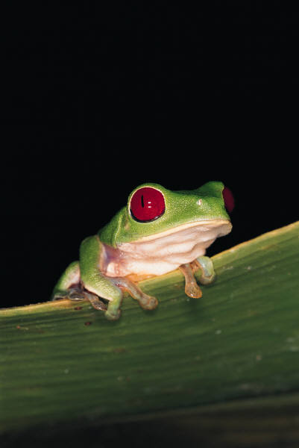  Personal and Social  *Personal Development  *Develop an awareness of what they are good at.  *Understand how they can improve their learning and use feedback to improve their work.  Social and Moral Development  *Understand that rules are essential in an ordered community.  *Develop a positive self image.  *Develop a sense of belonging as part of different communities.  *Begin to understand the diversity of roles people play in different groups and communities.  *Ask questions about how and why things should be treated with respect.  Well Being  *Understand relationships between feelings and actions.  *Demonstrate care, respect and affection for children, adults and the environment.  *Become interested in the world around them.  *Understand changes in their body as they exercise and describe them.  *Understand that exercise, hygiene and the right foods are important for health. | Mathematical Development  Number Skills  Read and write numbers to at least 10.  Compare and order numbers to at least 10.  Understand that zero means ‘none’  Use ordinal numbers to 10 in daily activities and play.  Calculate using mental and written methods  Mentally recall ‘one less’ of a number within 10.  Take away objects to find out ‘how many are left’?  Talk about addition and subtraction instructions in play activities.  Time  Sing chant days of the week  Months of the year  Demonstrate a developing sense of how long tasks take and everyday events take.  Area and volume  Use prepositions to describe position  Shape  Using data skills  Record collections using marks, numbers or  pictures  pattern  recognise and repeat three object patterns.
 | 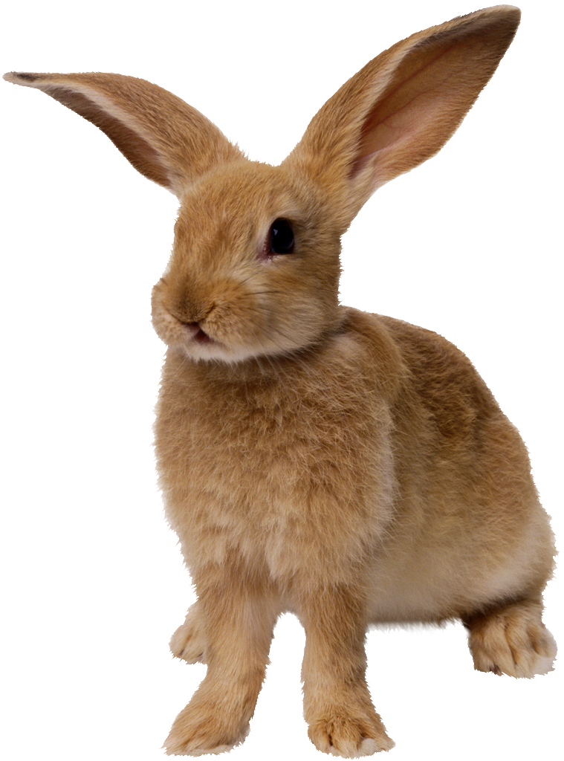
Creative Development  Art, Craft and Design  - Explore and experiment with a variety of techniques.  - Explore and experiment with a variety of materials  Mix, shape arrange and combine materials to create their own images and objects that communicate and express their ideas, feelings and memories creatively.  *Reflect on their own and others work.  Music  - Listen and respond to music  - Create their own musical ideas.  - Make broad distinctions between musical elements when listening to music.  Creative Movement  *Work independently with a partner, or a small group to develop their own and others’ ideas,  Develop control by linking movements to create a series of changing body shapes and pathways. | ICT  Citizenship: Identity, Image &reputation  Recognise that data can be shared online e.g. with adult support, find images of themselves and others for instance on the school website/school social media page etc.  Citizenship: Digital Rights, licensing & ownership  Find the name of the author on digital work  Interacting and Collaborating : Communication  Talk about different forms of online communication e.g. e-mail, messaging, video call and their uses.  Storing and Sharing  Save work by clicking an icon and understand that the work can be retrieved.  Planning, Sourcing and Searching  Identify a success criterion in response to questions e.g. success criteria may include ensuring the subject is in the middle of the image when taking a photograph.  Creating  Select appropriate software from a limited range to create multimedia components create and explore the use of text, image, sound, animation and video.  Evaluating and improving  Comment on work in relation to a single success criterion eg add comments using recording feature in software.  Problem solving and modelling  Create verbal instructions  Data and information literacy  Create a simple pictogram using suitable software. | Physical Development  Personal  - Develop sensory awareness  - Link actions in sequence  - Develop confidence  - Develop fine motor skills  - Control body movements  * Improve control and use of shapes, levels and directions  Adventurous and Physical Play  - Transfer weight from hands to feet when travelling on the floor  - Transfer weight from hands to feet when using a range of equipment and apparatus  - Play simple cooperative and competitive games  Health, Fitness and Safety  *Recognise the effects exercise have on their bodies  *Understand that regular exercise improves health and fitness and helps body parts work well.
Knowledge and Understanding of the World  * Ask questions and listen to answers  - Thinking about questions  - Identify what they want to find out  - Identify how to find out what they want to know  *Sort and group information  *Use ICT to sort and group information  * Listen to others’ ideas  - Make comparisons  - Become aware of Big ideas that have shaped the world  - Recognise simple patterns in their findings  - Use and become familiar with common words and phrases for their world  - Offer simple explanations  - Express own opinions and feelings | Habits of Mind  Little Miss Continuous Learning  Little Miss Accuracy | Welsh Language Development  Oracy  Make themselves understood [O1]  Show that they understand basic instructions [O2]  Listen to familiar and unfamiliar voices [O3]  View and listen carefully to a variety of visual and audio-visual stimuli [O5]  Understand that there is variety in the language they hear around them [O11]  Reading  follow stories read to them and respond as appropriate [R1]  listen to others reading appropriate imaginative material [R2]  look at books, handling them as a reader, with or without an adult [R3]  listen to a story being read by following the print [R4]  read aloud their own work and other printed resources [R7]  re-read extracts that have been enjoyed and memorise passages  begin to read independently [R8]  show an understanding of what they or others have read by responding orally or non-verbally to the content. [R9]  Writing  Communicate by: – experimenting with mark-making, using a variety of media – producing emergent writing [W1]  Begin to write in a conventional way, communicating by using words, phrases and short sentences, Linked to familiar patterns [W6]  Organise and present imaginative and factual writing in different ways, helpful to the purpose, task and reader, using ICT as appropriate [W9]  Colour Key  Blue – Expressive Arts  Green – Health and well being  Red – Humanities  Purple- Science and Technology

