Step 1: Fold a letter-sized (8.5″ x 11″ or A4) piece of paper or cardboard in half, making a neat crease along the middle.
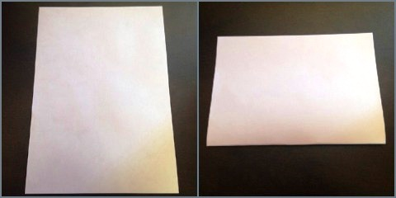
Start by folding your paper in half.
Step 2: Fold the two corners of the folded edge inwards toward the middle, so that the top makes a point.
Step 3: Now, fold the bottom loose rectangular ends up toward the end of the triangles. Then turn the boat over and repeat on the other side. The boat should look like a hat.
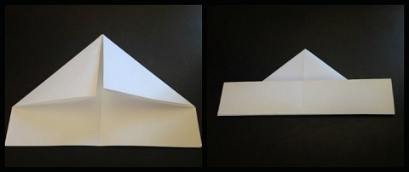
Fold the edges along the crease inward and then fold up the loose ends on both sides.
Step 4: Fold the bottom corners inward. Flip the boat over and fold the other side.
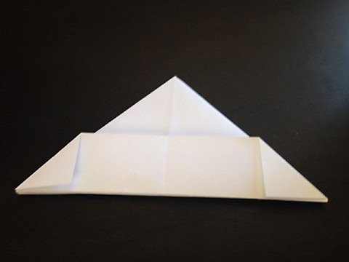
Fold the bottom corners inward on both sides, so the paper is in the shape of a triangle.
Step 5: Next, open up the boat into the hat shape and then fold it over into a square.
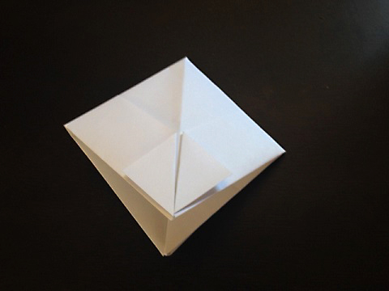
Fold the triangle back into a square.
Step 6: Fold the bottom flaps upward—toward the top corner—and form another triangle.
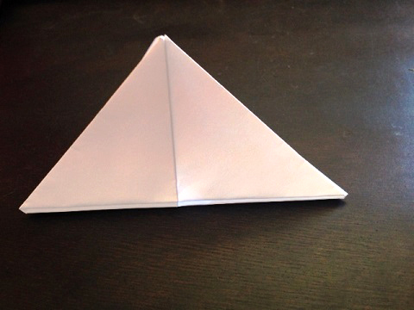
Fold up the bottom flaps toward the top corner to form another triangle.
Step 7: Now take the triangle, shift it and make it into a square. (I know; again. Be patient, we are almost done.)
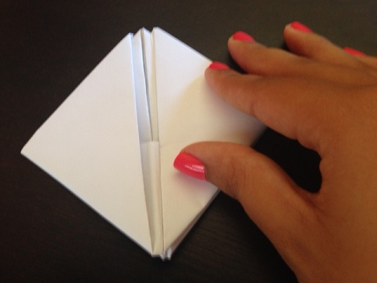
Shift the triangle into another small square.
Step 8: Take the top corners and pull them down to reveal your paper boat.
